# I mRefrece to dll

Like System.Drawing.dll

Unity Folder%\Editor\Data\Mono\lib\mono\2.0

# Tags

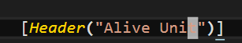



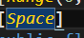

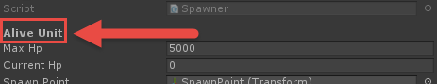



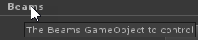

# Character Move

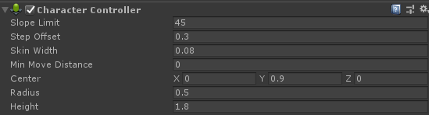

If you don’t wan’t character to move throw the walls use the charactercontroller

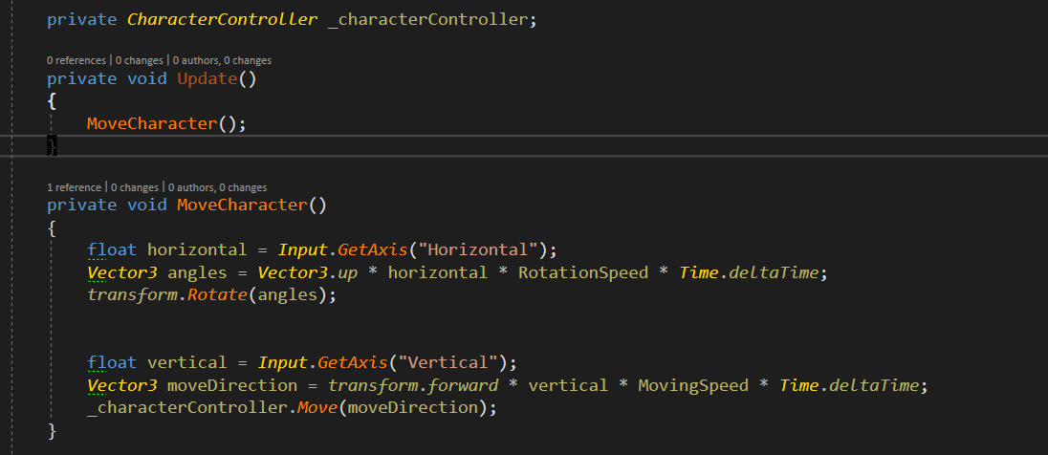

# Instruments

## Visual studio Extensions

[Official Documentation](https://docs.microsoft.com/en-us/visualstudio/cross-platform/visual-studio-tools-for-unity)

[Guy from Visual Studio Tools for Unity](https://forum.unity3d.com/threads/unityvs-default-namespace-keeps-resetting.262601/)

Custom project file creation

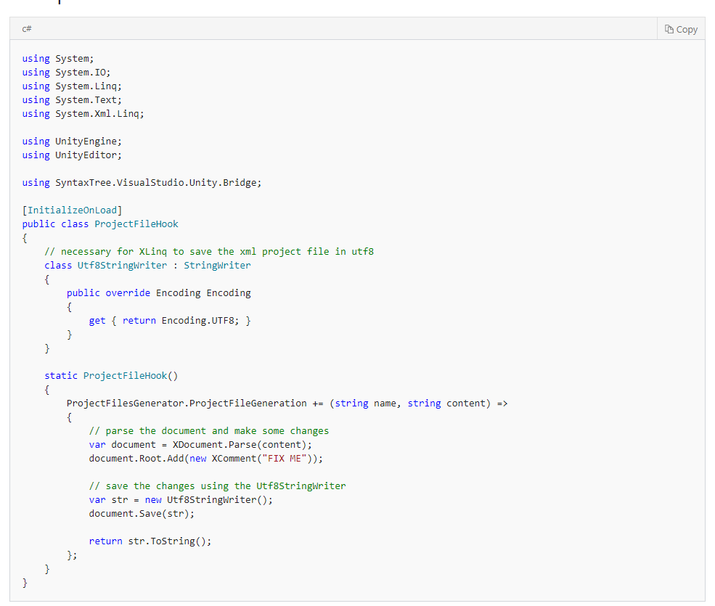

Change Root File

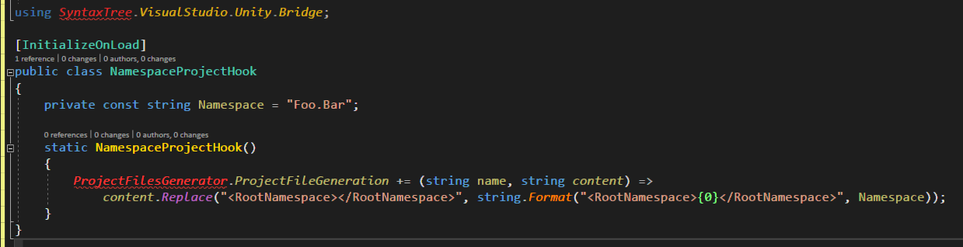

## Animator and animation

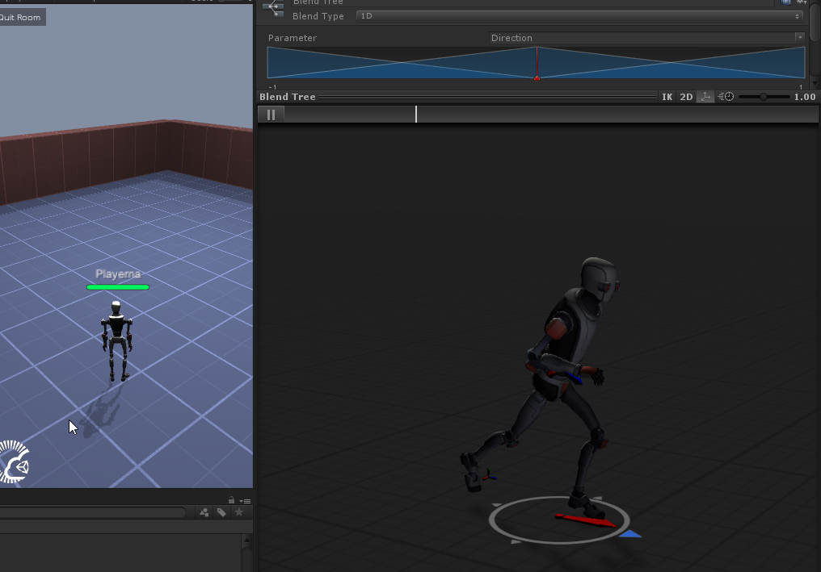

I found out that animation can move the character forward I wan’t to try it out.

## Ragdoll

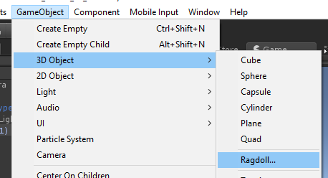

## Timeline Playable and Graphs

## Timeline

Timeline – is basic tool for cutscene and gameplay animation integration

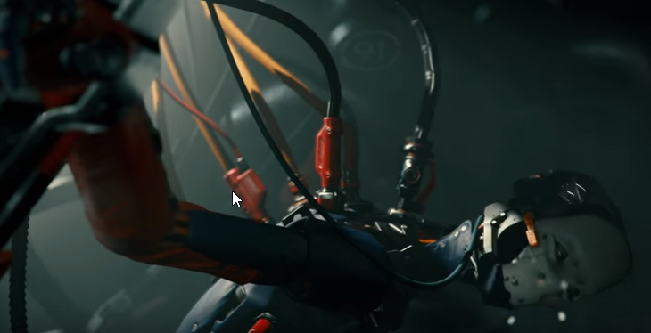

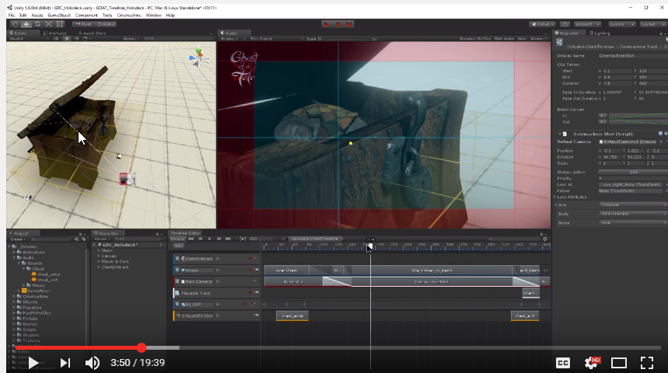

### Resources

1. [Official manual](https://docs.google.com/document/d/1gHmNTNIsn_yuzlURnaTFDxt24vf-8QyUcjtTgbZiKsk/pub)
2. [Video from Unity 1](https://www.youtube.com/watch?v=oZRp8c1Wv-o) (basics)
3. [Playble API scriping](https://www.youtube.com/watch?v=5KSaHcsSVa4)
4. [Awesome video](https://www.youtube.com/watch?v=5KSaHcsSVa4)

### Code



### Playable Graph

Just visualization of grpahs blanding

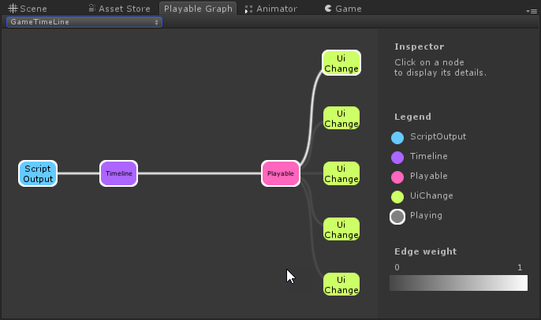

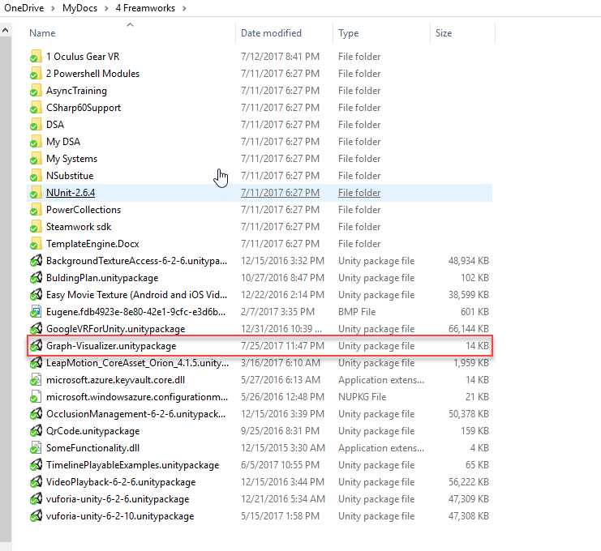

### Shortcuts

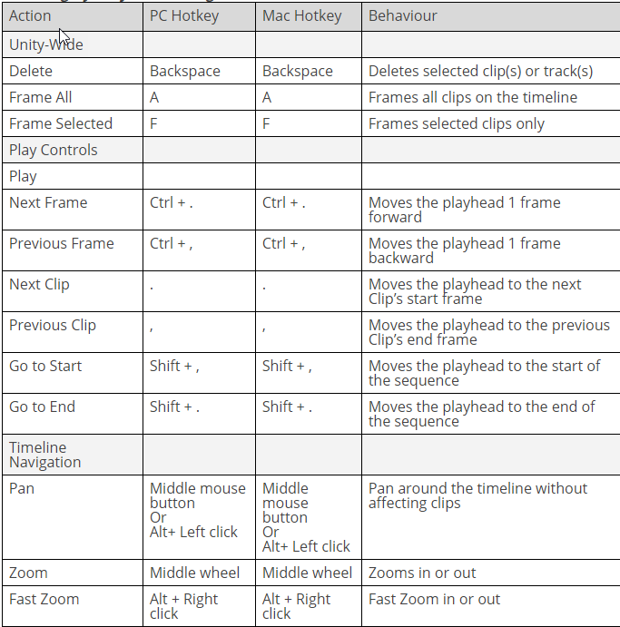

## Playable API

Okay so in simple words it’s way to mix timeline with Scripts.

### Resources

1. [Playable official (new)](https://docs.unity3d.com/Manual/Playables.html)
2. [Timeline official document](https://docs.google.com/document/d/1gHmNTNIsn_yuzlURnaTFDxt24vf-8QyUcjtTgbZiKsk/pub)
3. [Scripting official](https://docs.unity3d.com/ScriptReference/Playables.ScriptPlayable_1.html)

1. [Awesome video](https://www.youtube.com/watch?v=5KSaHcsSVa4)
2. [ScriptPlayabl and PlayableBehaviour](https://docs.unity3d.com/Manual/Playables-ScriptPlayable.html)

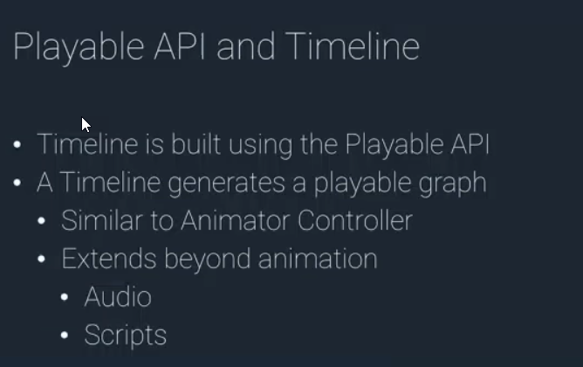

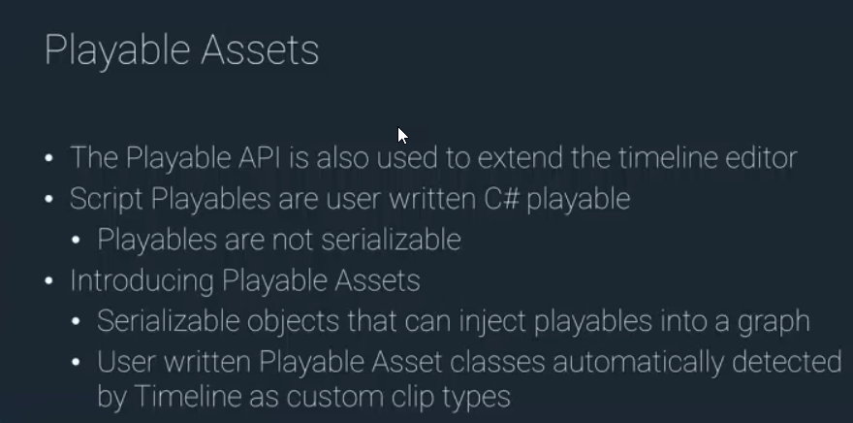

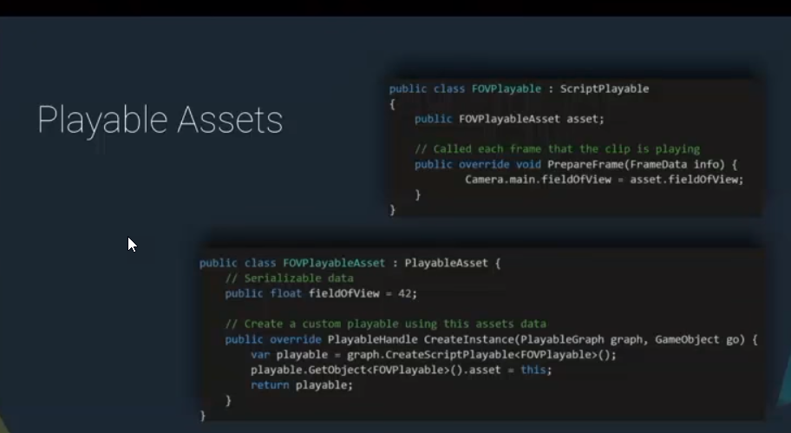

### Playable Behaviour

In old times it was ScriptPlayable

It is used to do something in timline

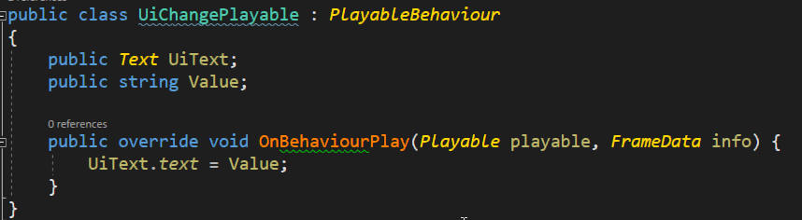

#### OnGraphStart and OnGraphStop

*OnGraphStart*and *OnGraphStop* are called when the Timeline starts and stops playing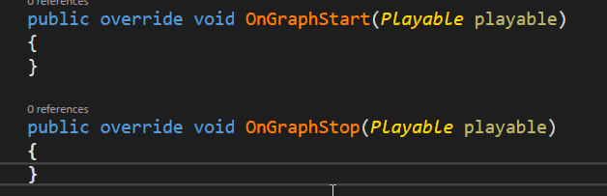

#### Preparing and processing frame

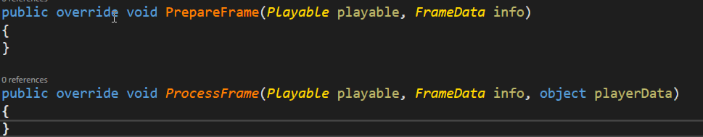

### Playable Asset

Script that will run on time line and it’s awesome

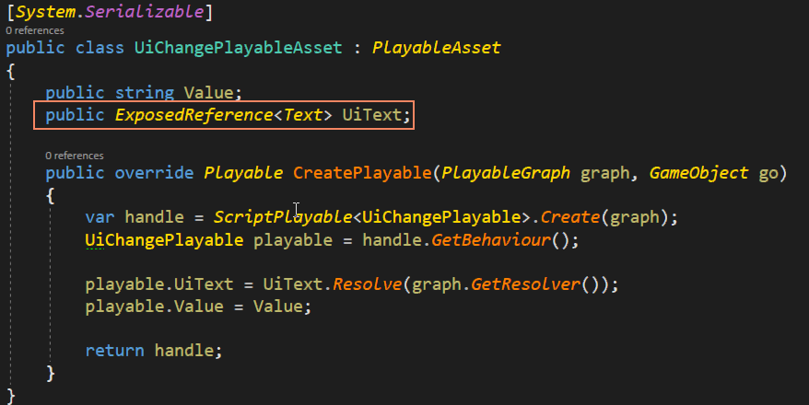

Link to object in scene

 - to link something in scene

 - get instance

#### On TimeLine

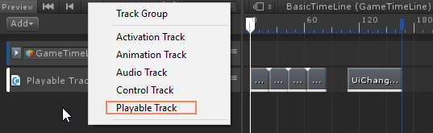 - playable assets are on playable track

#### Add to track

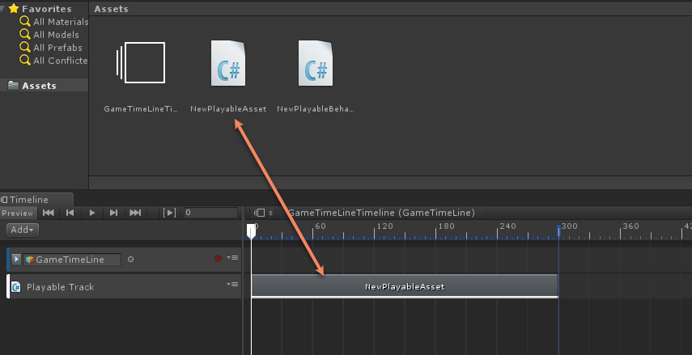

Okay so playable assets creats playable script and then we use plabye to control our object.

## Exposed reference



[Official doc](https://docs.unity3d.com/ScriptReference/ExposedReference_1.html)

I simple words it can be used for assets to have runtime reference to and object such as a [ScriptableObject](https://docs.unity3d.com/ScriptReference/ScriptableObject.html) or [PlayableAsset](https://docs.unity3d.com/ScriptReference/Playables.PlayableAsset.html) to create references to scene objects.

## Playable Graph

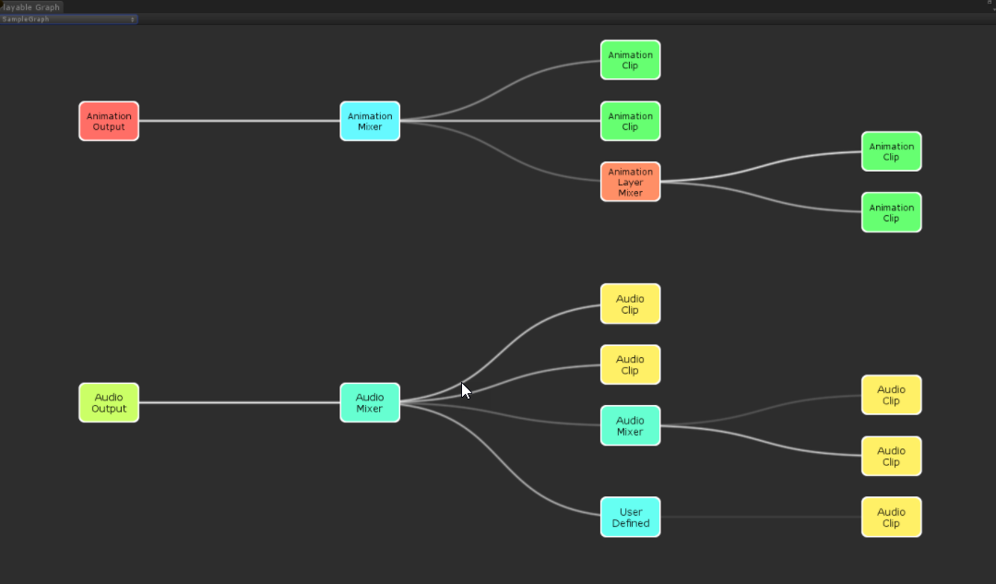

### Resources

1. [Documentation with cool examples](https://docs.unity3d.com/Manual/Playables-Examples.html)
2. [Documentation into](https://docs.unity3d.com/Manual/Playables-Graph.html)
3. [GitHub Graph visualizer](https://github.com/UnityTech/graph-visualizer)

## Assembly definition

[Official blog post](https://blogs.unity3d.com/2017/11/22/unity-2017-3b-feature-preview-assembly-definition-files-and-transform-tool/)

So in order to prevent recompiling the same script over and over again we now have assembly definition

So we can separate our code into multiple assemblies and then use them as long as we need.

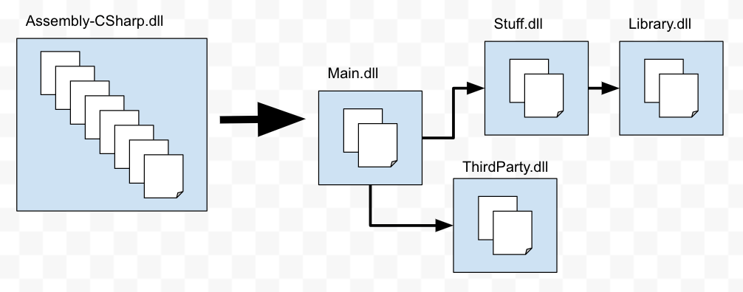

Creation of assembly definition

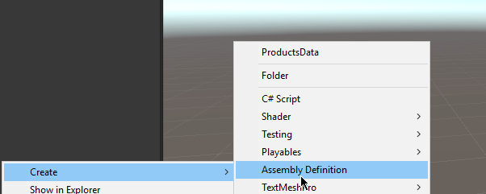

And lest you need to reference each other in order to work properly

# Comand Line(Cloud Building)

## Resources

1. [Official Documentation](https://docs.unity3d.com/Manual/CommandLineArguments.html)

## Launch Unity Silently

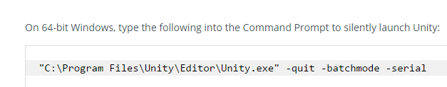

# Editor Scripting

Don’t forget to put in the Editor folder incide the Assets anywhere

All scripts expending inspector should be in Editor folder

## Refrences

[Extending inspector 1 video](https://unity3d.com/ru/learn/tutorials/topics/interface-essentials/property-drawers-custom-inspectors)

[Editor extension very date article](https://unity3d.com/ru/learn/tutorials/topics/interface-essentials/unity-editor-extensions-menu-items)

[EditorGUILayout documentation](https://docs.unity3d.com/ScriptReference/EditorGUILayout.html?_ga=2.161101181.1973185857.1512314948-1329817958.1511976268) is bassicly what we using for all editor scripts

## Odin

Editor scripting in better way

[link](http://sirenix.net/odininspector/manual/introduction/design-with-attributes)

Odin is awesome.

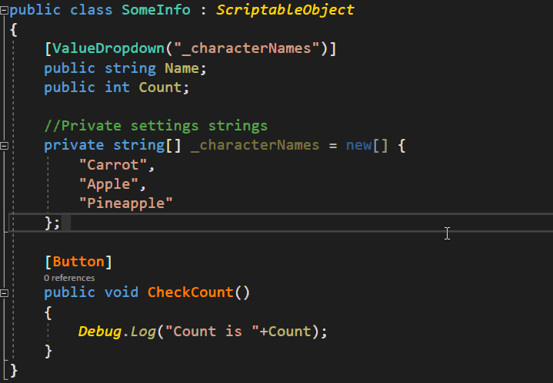

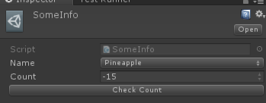

### Odin Editor Only mode

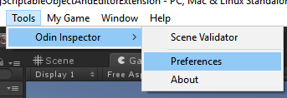

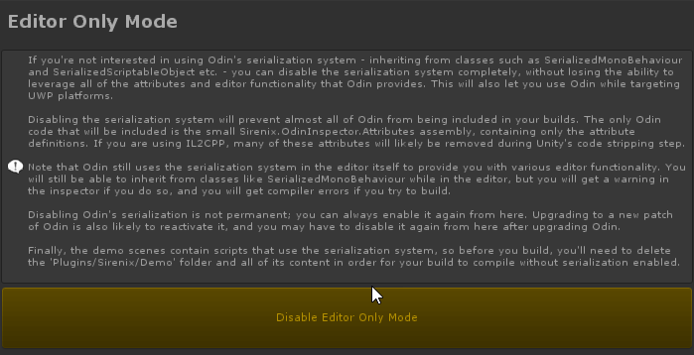

### Best attributes

#### Title and title groups

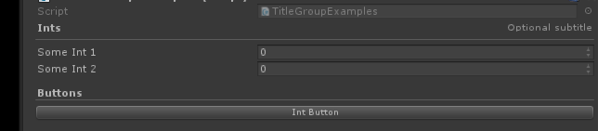

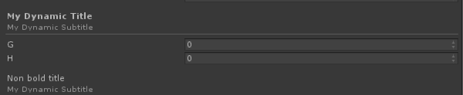

#### ValueDropDown

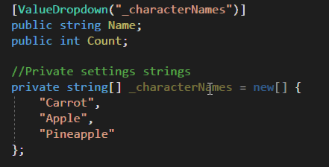

#### Button

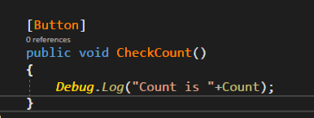

#### TableList

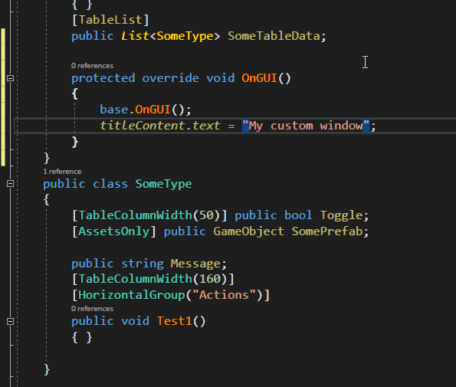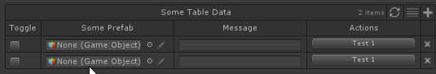

#### Tabs

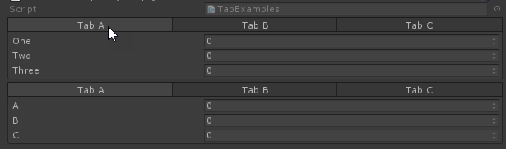

#### Foldout groups

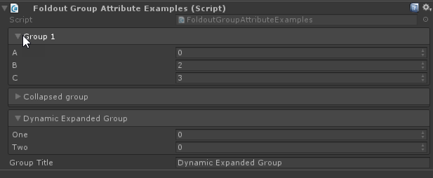

#### Toggles

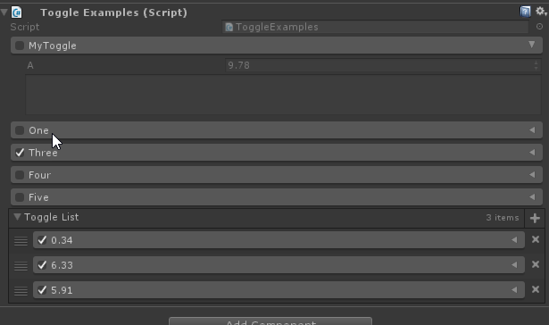

#### Inline Editor

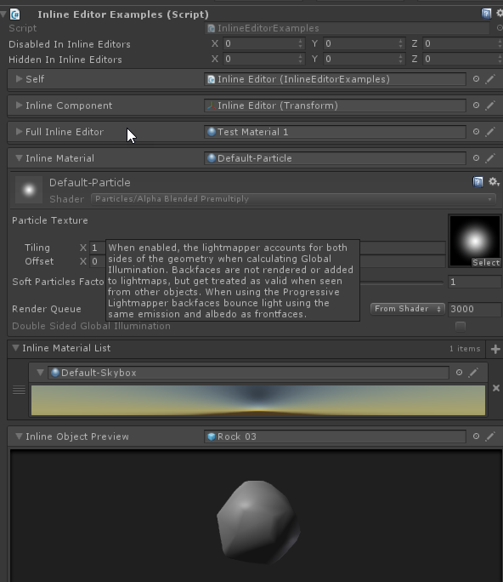

#### Enum Toggle

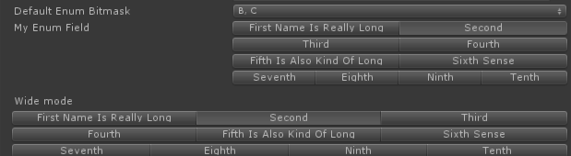

#### Dictionarys

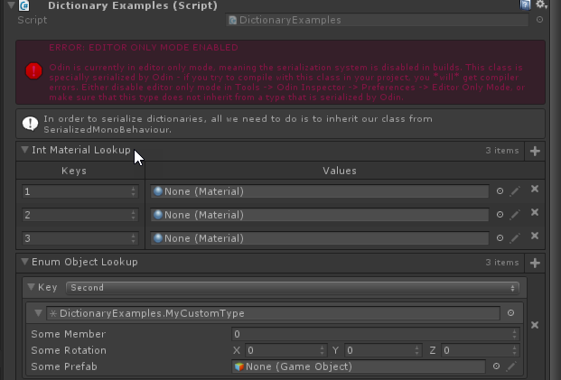

#### Custom context menu

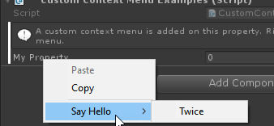

#### Enable in editor disable in play mode

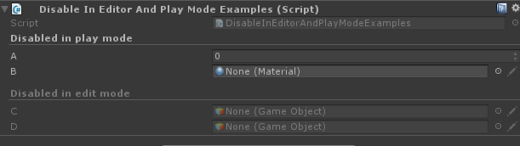

#### ON Value change

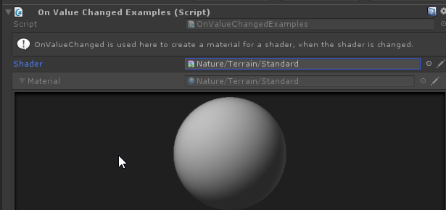

#### Scene only asset only

### Custom Editor Window

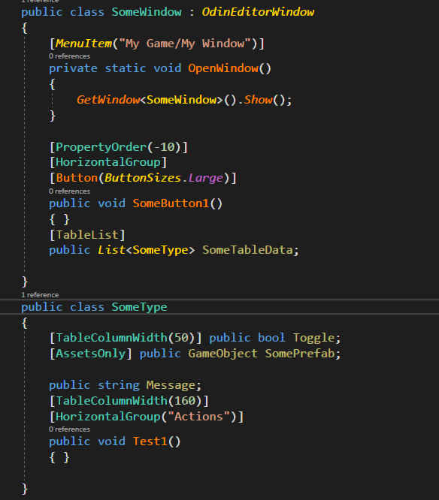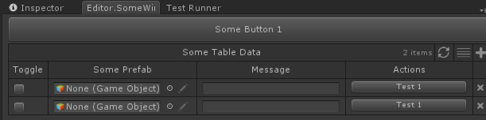

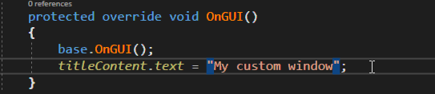

### Specia paths

<https://unity3d.com/de/learn/tutorials/topics/interface-essentials/unity-editor-extensions-menu-items>

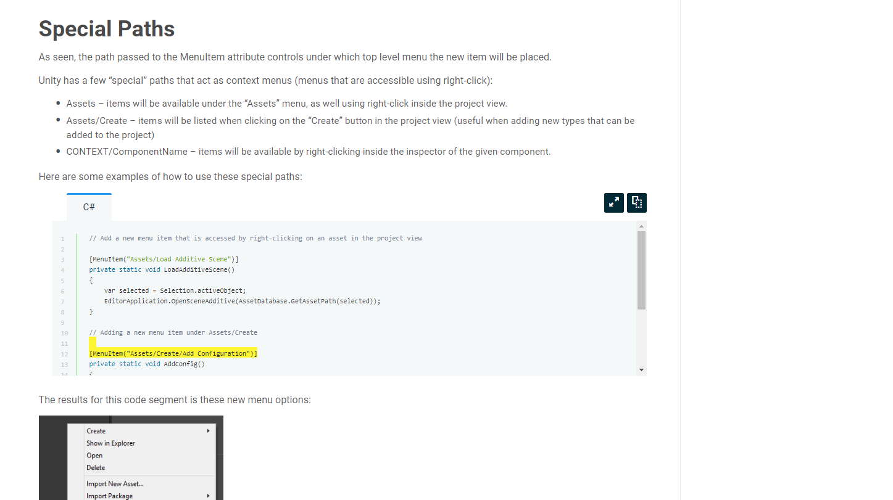

## Context Menu

### Link

<https://unity3d.com/learn/tutorials/topics/interface-essentials/unity-editor-extensions-menu-items>

To get path use

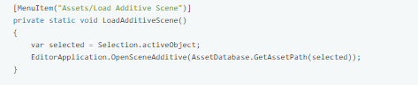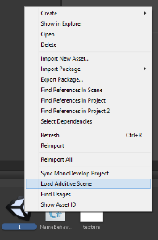

### Project Widnwo Util

To get path to current folder in Project window.





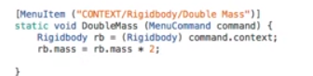

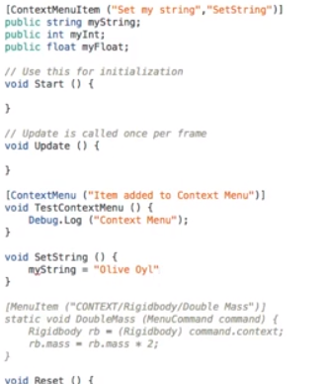

## Creating custom handlers for drag and droping



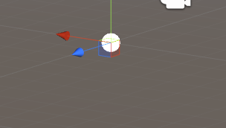

## Create and select gameobject

## Add Menu Items

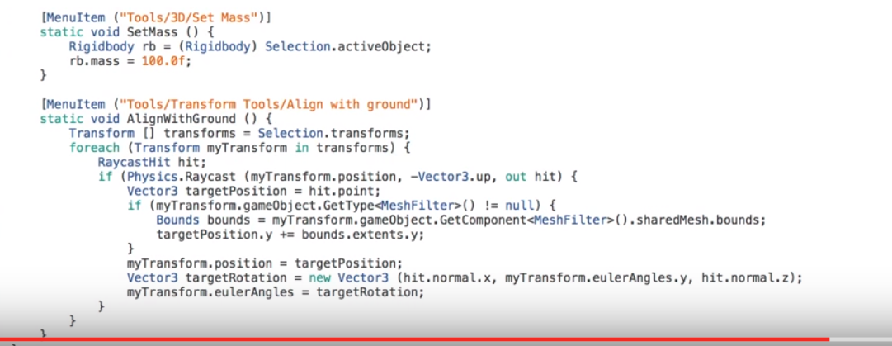

## Custom Editor Window

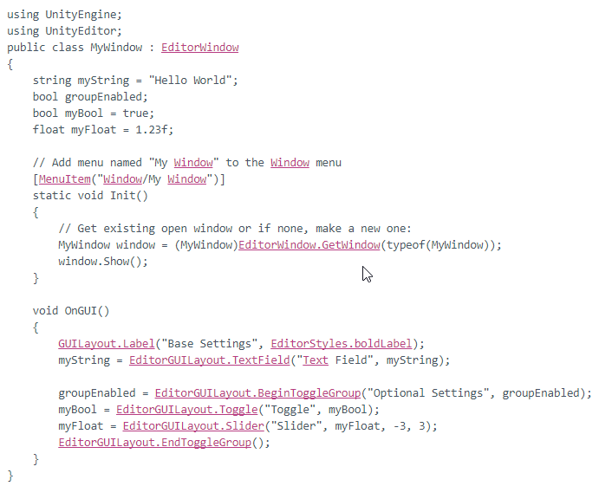



<https://docs.unity3d.com/ScriptReference/EditorGUILayout.Space.html> - great example of cofing

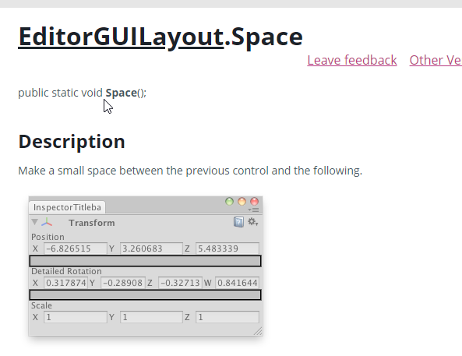

## Scriptable Object

### Creating with Unity test

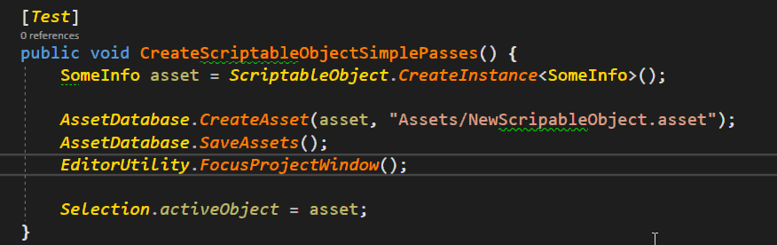

## Custom Editor for Item

[Extending inspector 1 video](https://unity3d.com/ru/learn/tutorials/topics/interface-essentials/property-drawers-custom-inspectors)

Create new window and inherete It from editor class

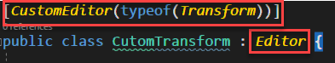

And costomotize for which class to use it.

## Breaking throw reflcation

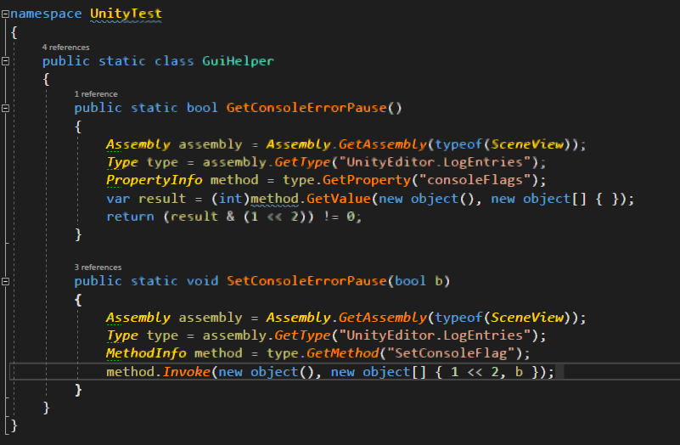

## Show message

<https://docs.unity3d.com/ScriptReference/EditorUtility.DisplayDialog.html>

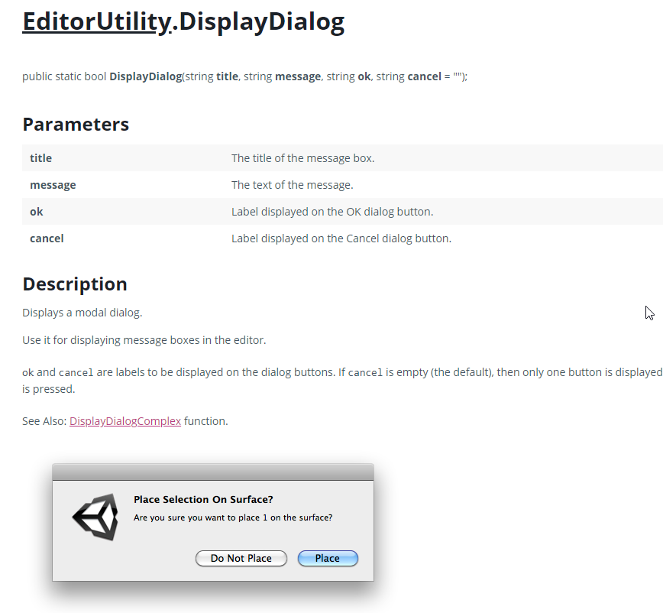

# IL2CPP

The IL2CPP – is more advanced scripting back end. Bring a highly-performant, highly-portable virtual machine

# Shaders

[Global shder reference](https://docs.unity3d.com/Manual/SL-Reference.html)

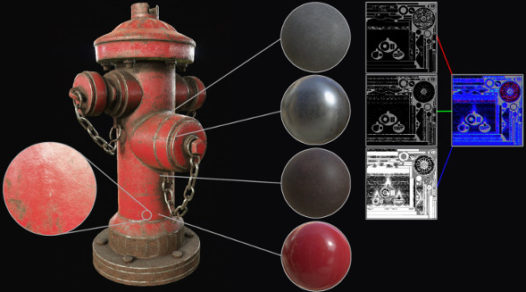

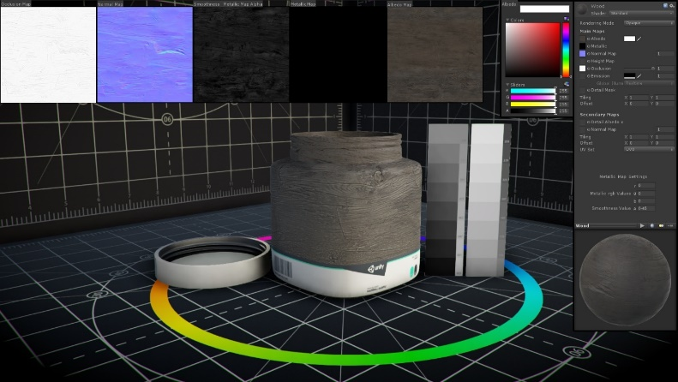

## Shader types

Cg/HLSL (C for Graphics)/(**H**ight **L**evel **S**hader **L**anguage)

ShaderLab - Unity thing for creating the shaders.

Surface Shaders – the shader that is effected by light and shadows !(Don’t use if not interfering with light)

Vertex and Fragment Shaders – if you don’t interact with lightning.

Fixed Function Shaders – Legacy shaders. They writedin ShaderLab language.

## CG/HLSL

[Link to Unity](https://docs.unity3d.com/Manual/SL-ShaderPrograms.html)

## Shader Lab

[Shader lab unity](https://docs.unity3d.com/Manual/SL-Shader.html) All Shder files are written in declarative lanuigage called “ShadeLab”

Shader – is the root command that can define one and only one shader.

### Properties

<https://docs.unity3d.com/Manual/SL-Properties.html>

The visual representation of input data.

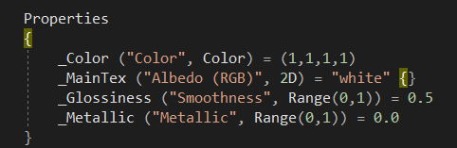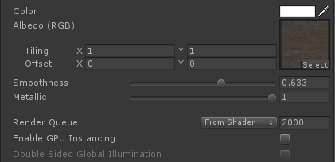

### SubShaders & Fallback

[SubShader](https://docs.unity3d.com/Manual/SL-SubShader.html)

Exactly the shader.

We try to write shader in as less passes as possible.

#### Syntax

SubShader{ [Tags] [CommonState] Passdef [Passdef..] }

[Fallback](https://docs.unity3d.com/Manual/SL-Fallback.html)

### Pass

### Synax

Pass { [Name and Tags] [RenderSetup] }

### UsePass

### GrabPass

### Tags

If non of the SubShaders can’t be handle by current graphic carad. Then we go and use the fallback shader

# Shader forge in your unity assets

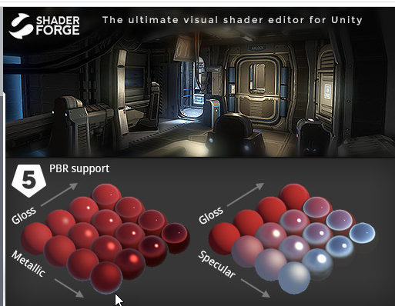

In your unity tools

# AndroidManifest.xml

[Unity Link](https://docs.unity3d.com/Manual/android-manifest.html)

But in simple words it’s your player settings.

# VR

## Reference global

1. [Unity Optimization](https://unity3d.com/learn/tutorials/topics/virtual-reality/optimisation-vr-unity)
2. [Squeezing Performance in Unity](https://developer.oculus.com/blog/squeezing-performance-out-of-your-unity-gear-vr-game/)
3. [Squeezing Performance in Unity part 2 (Profiler)](https://developer.oculus.com/blog/squeezing-performance-out-of-your-unity-gear-vr-game-continued/)

## Gear VR

It looks like best archttecture is not x86 but ARM highest version.

### Resources

The main thing about all those resources that you should use Oculus and Unity bought at same time.

1. [Oculus Sign](https://dashboard.oculus.com/tools/osig-generator/)
2. [Oculus Downloads for Unity](https://developer.oculus.com/downloads/unity/)
3. [Prepering for Mobile development](https://developer3.oculus.com/documentation/game-engines/latest/concepts/unity-mobileprep/)
4. [Simple VR Unity game](https://developer3.oculus.com/documentation/game-engines/latest/concepts/unity-tutorial-rollaball-intro/)
5. [Oculus Mobile development Unity](https://developer3.oculus.com/documentation/game-engines/latest/concepts/unity-mobile-performance-intro/)
6. [Oculus official documentation](https://developer3.oculus.com/documentation/mobilesdk/latest/)
7. [Preparing SDK](https://developer3.oculus.com/documentation/game-engines/latest/concepts/unity-mobileprep/)
8. [Device Setup](https://developer3.oculus.com/documentation/mobilesdk/latest/concepts/mobile-device-setup/)
9. [Oculus Unity guide](https://developer3.oculus.com/documentation/game-engines/latest/concepts/book-unity/)
10. [Oculus Utilities for Unity](https://developer3.oculus.com/documentation/game-engines/latest/concepts/unity-utilities-overview/#unity-utilities-overview)
11. [Oculus Remote Monitor for Android Studio](https://developer.oculus.com/documentation/mobilesdk/1.0.3/concepts/mobile-remote-monitor/)
12. [Oculus Remote Monitor for Unity](https://developer.oculus.com/documentation/mobilesdk/latest/concepts/mobile-capture-intro/)
13. [Running without headset](https://developer.oculus.com/documentation/mobilesdk/latest/concepts/mobile-troublesh-device-run-app-outside/)
14. [Command Line Utility](https://dashboard.oculus.com/tools/cli)
15. [Best Practice for GearVR](https://developer.oculus.com/documentation/unity/latest/concepts/unity-best-practices-intro/)

### Getting Started

[Ocululs build first VR app guide](https://developer3.oculus.com/documentation/game-engines/latest/concepts/unity-tutorial/)

[Prepering for mobile development](https://developer3.oculus.com/documentation/game-engines/latest/concepts/unity-mobileprep/)

simple guiede

1. 
2. 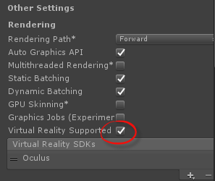
3. Assets>Import Pckage>Custom Package
4. [Oculus Utilites for Unity](https://developer.oculus.com/downloads/package/oculus-utilities-for-unity-5/) or Documents\4 Freamworks\OculusUtilities
5. [Unity simple framework](https://developer.oculus.com/downloads/package/oculus-sample-framework-for-unity-5-project/) as well s good Documents\4 Freamworks\OculusUtilities
6. Add sign osig to 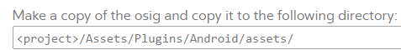

### Input

[Link to resource](https://developer3.oculus.com/documentation/game-engines/latest/concepts/unity-ovrinput/)

IN simple words you just use instead of Input you use ORInput

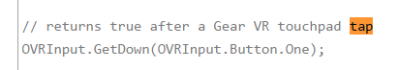

#### Virtual Mapping

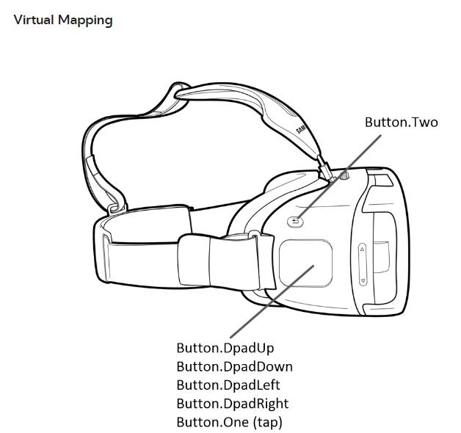

#### Raw Mapping

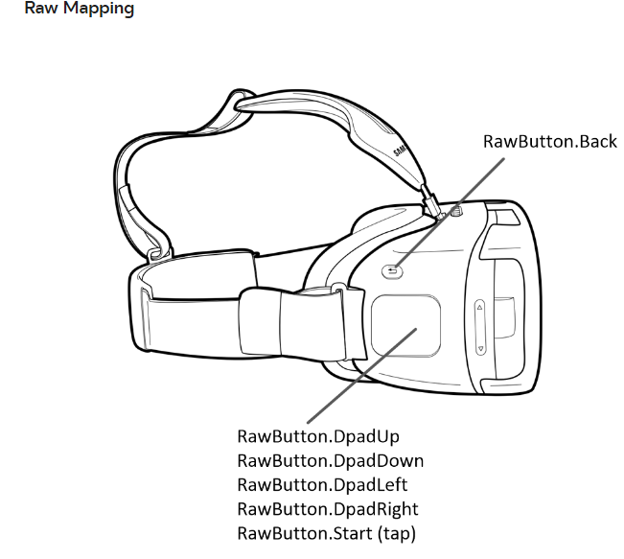

#### GearVR Controller

[Baset Practice](https://developer.oculus.com/blog/gear-vr-controller-best-practices/)

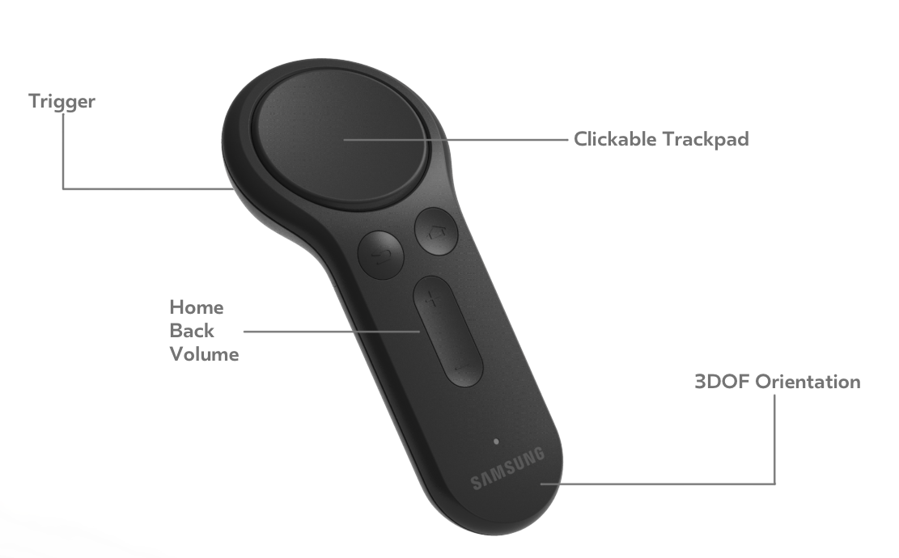

To use the controller.

OVRInput.Controller

Okay so as always we will use OVRInput.

RTrackedRemote or LTrackedRemote. – there to types of controller left handed and right handed.

##### Mapping

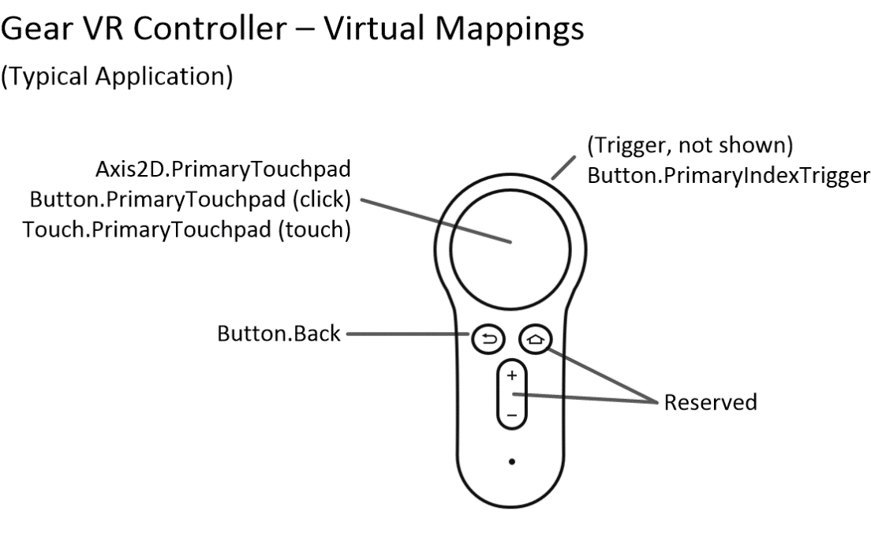

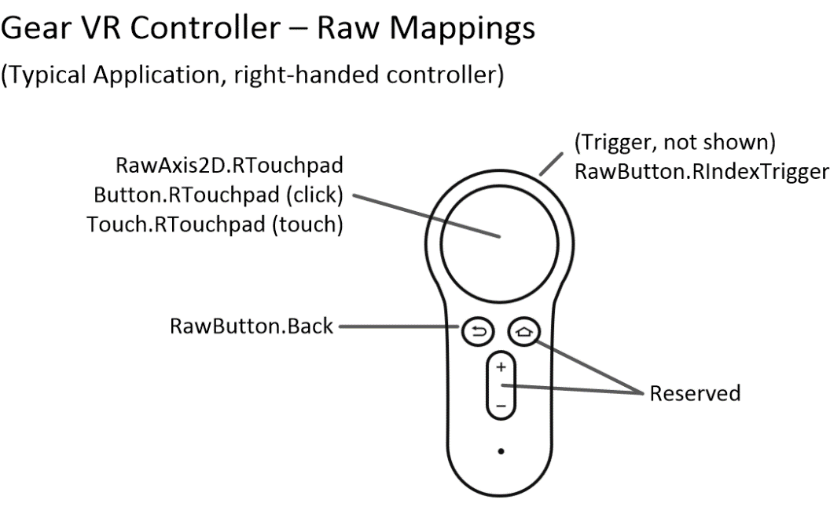

##### Examples

###### Check is controller

// returns true if right-handed controller connected

OVRInput.IsControllerConnected(OVRInput.Controller.RTrackedRemote);

###### Getting Rotation

// get the orientation of a right-handed remote

Quaternion rotation = OVRInput.GetLocalControllerRotation(

OVRInput.Controller.RTrackedRemote);

###### Touchpad Input

OVRInput.Get(OVRInput.Axis2D.PrimaryTouchpad, OVRInput.Controller.RTrackedRemote);

###### Reenter controller

OVRInput.RecenterController().

### Profiling

#### Adb

[Article](https://developer.oculus.com/documentation/mobilesdk/1.0.3/concepts/mobile-remote-monitor/)

adb logcat -s VrApi

#### Remote Monitor

[Setup Guide](https://developer.oculus.com/documentation/mobilesdk/1.0.3/concepts/mobile-remote-monitor/)

So you will see what’s going around

And to use it as native we aslo need android NDK.

[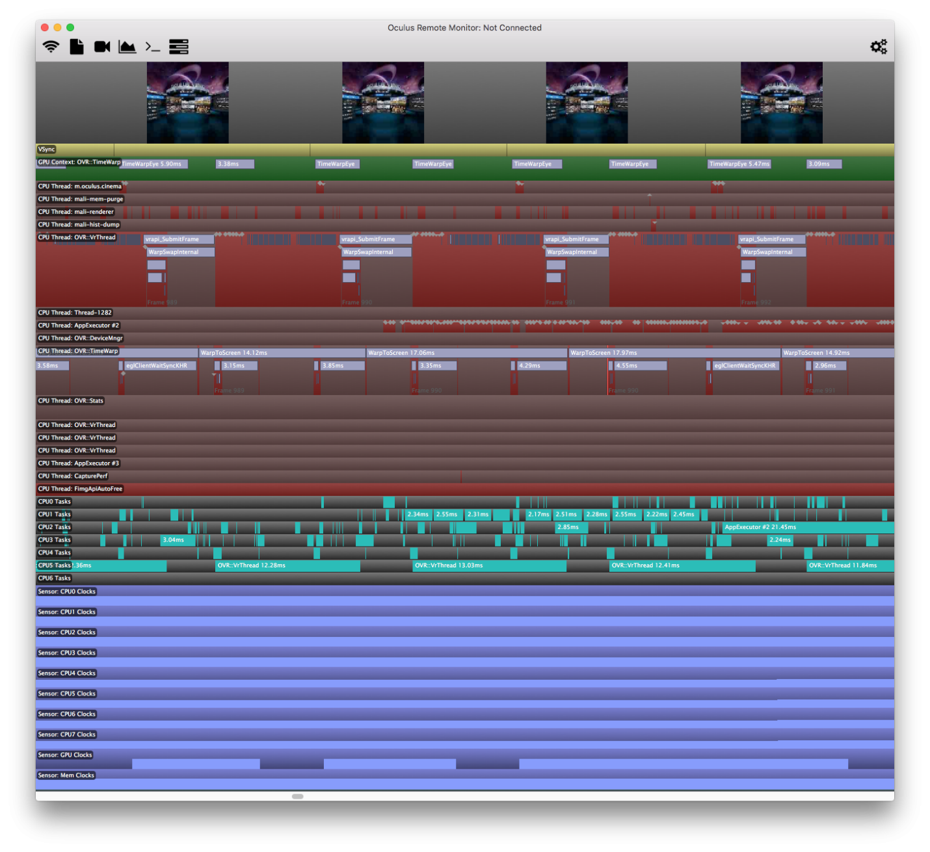](https://www.google.com.ua/url?sa=i&rct=j&q=&esrc=s&source=images&cd=&cad=rja&uact=8&ved=0ahUKEwi39p30yenUAhWiCJoKHRJNBEAQjRwIBw&url=https://forums.oculus.com/developer/discussion/36622/oculus-remote-monitor-1-0-3-released&psig=AFQjCNEkjj0--mMRQPmOi371rrWEvYnx7g&ust=1499049800005587)

### Texture Compression

[Official Documentation](https://docs.unity3d.com/Manual/class-TextureImporterAndroid.html)

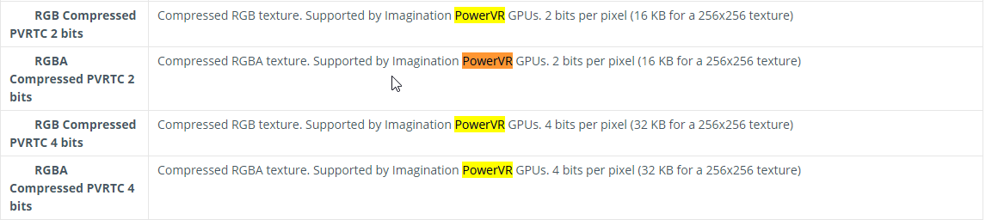

# Vuforia

Links

[Documentation](https://library.vuforia.com/sites/default/api/unity/classVuforia_1_1VuforiaARController.html)

[Image target optimiztion](https://library.vuforia.com/articles/Solution/Natural-Features-and-Ratings)

[Vumark design](https://library.vuforia.com/articles/Training/VuMark-Design-Guide)

[Dynamic load dataset](https://developer.vuforia.com/forum/faq/unity-load-dataset-setup-trackables-runtime)

## Improve image Quality

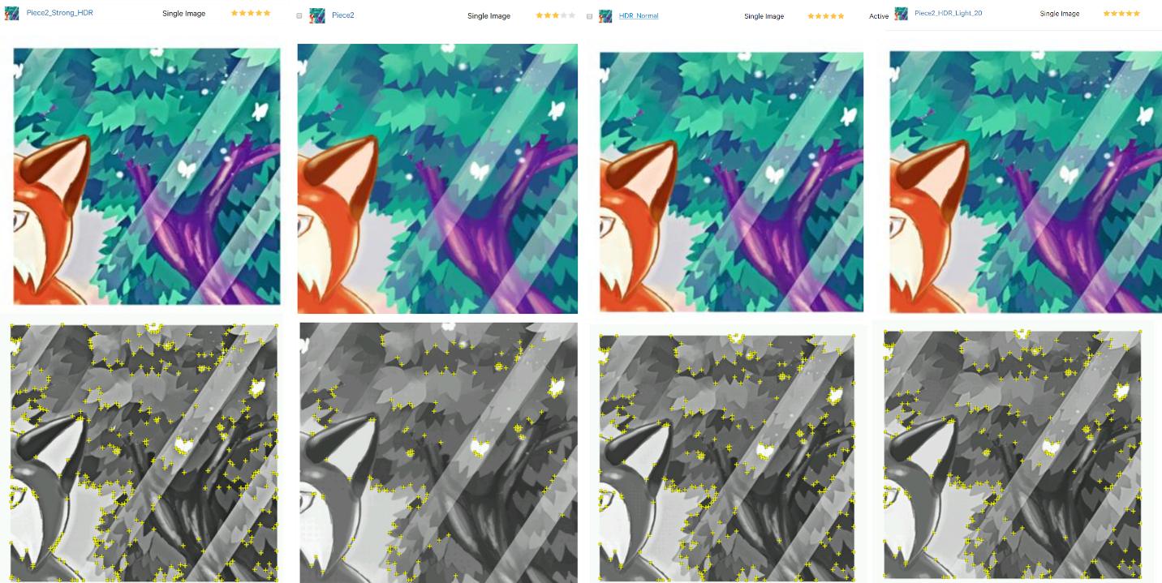

The perfect way is

Master contrast>HDR Light Contrast> transparency 20%

## Loading Dataset

If you register something to load



Don’t forget to unregister it 

# Machine Learning

## Resources

<https://unity3d.com/machine-learning>

<https://blogs.unity3d.com/ru/category/machine-learning/> - blog with all possible articles

<https://github.com/Unity-Technologies/ml-agents/blob/master/docs/Readme.md> - full documenation

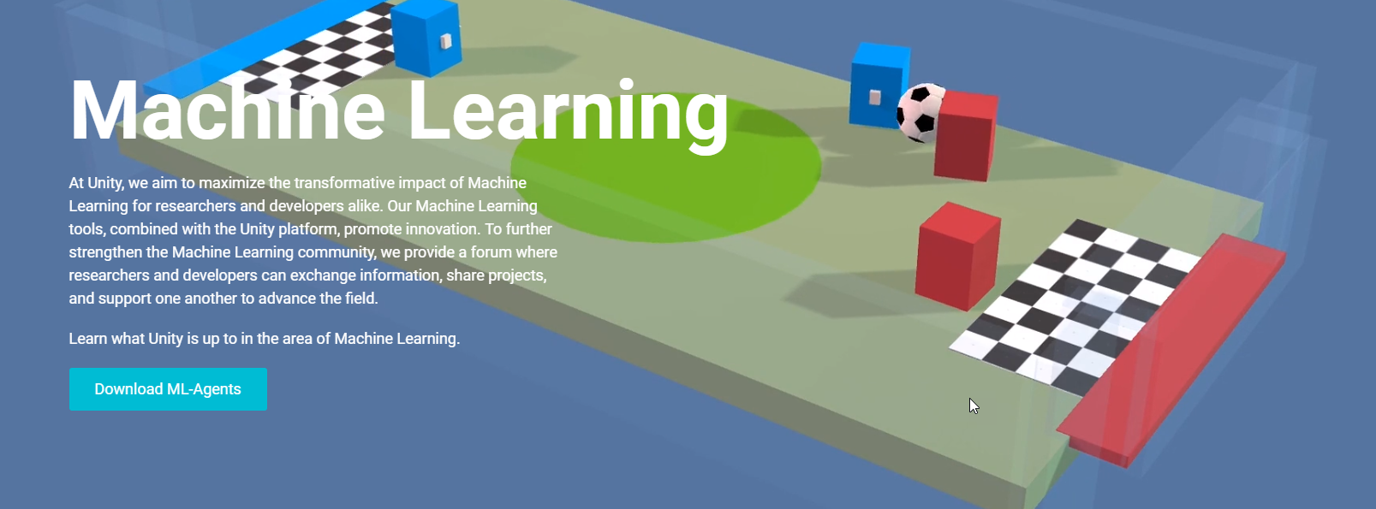

So we have this hole page for that.

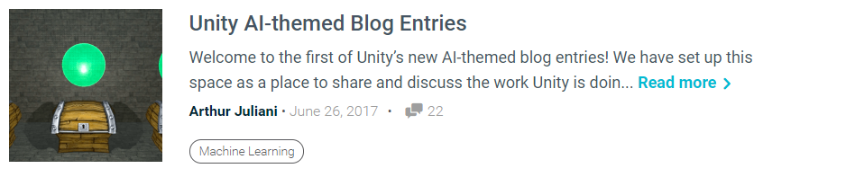

The Machine Learning trend started in Unity not so long ago .

And it’s sort of growing up. Looks like It become more and more trendy.

There is honestly tones of materials.

## Reinforcement learning

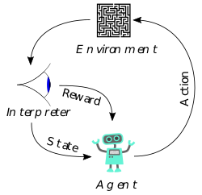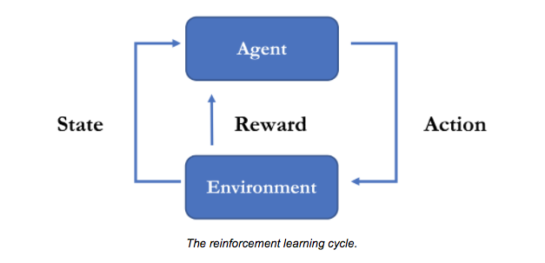

So in Unity we use reinforcement learning so every our action supported if it’s done correctly .

## Q-Learning

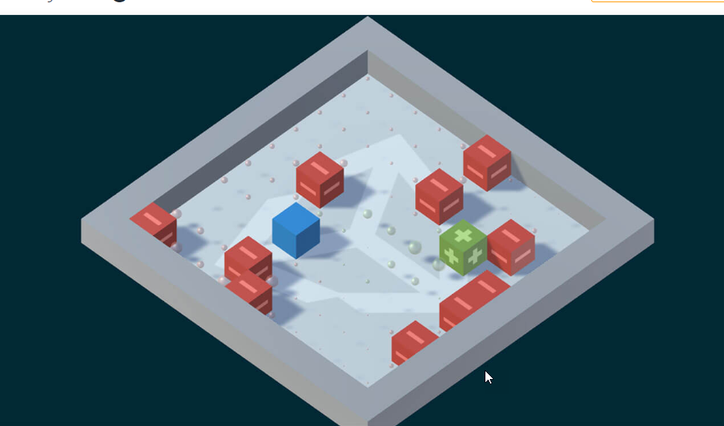

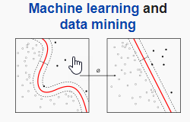]

Basicly saying threat the group of actions as one.

### Growes into

DeepMind’s

Deep Q-Network

## Unity Machine Learning toolkit

[Github](https://github.com/Unity-Technologies/ml-agents)

### Training Agent

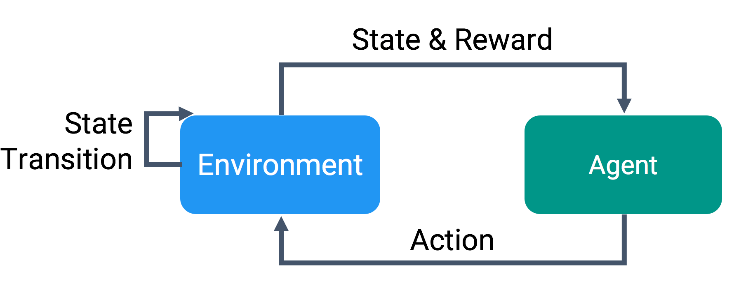

### Learning Envirment

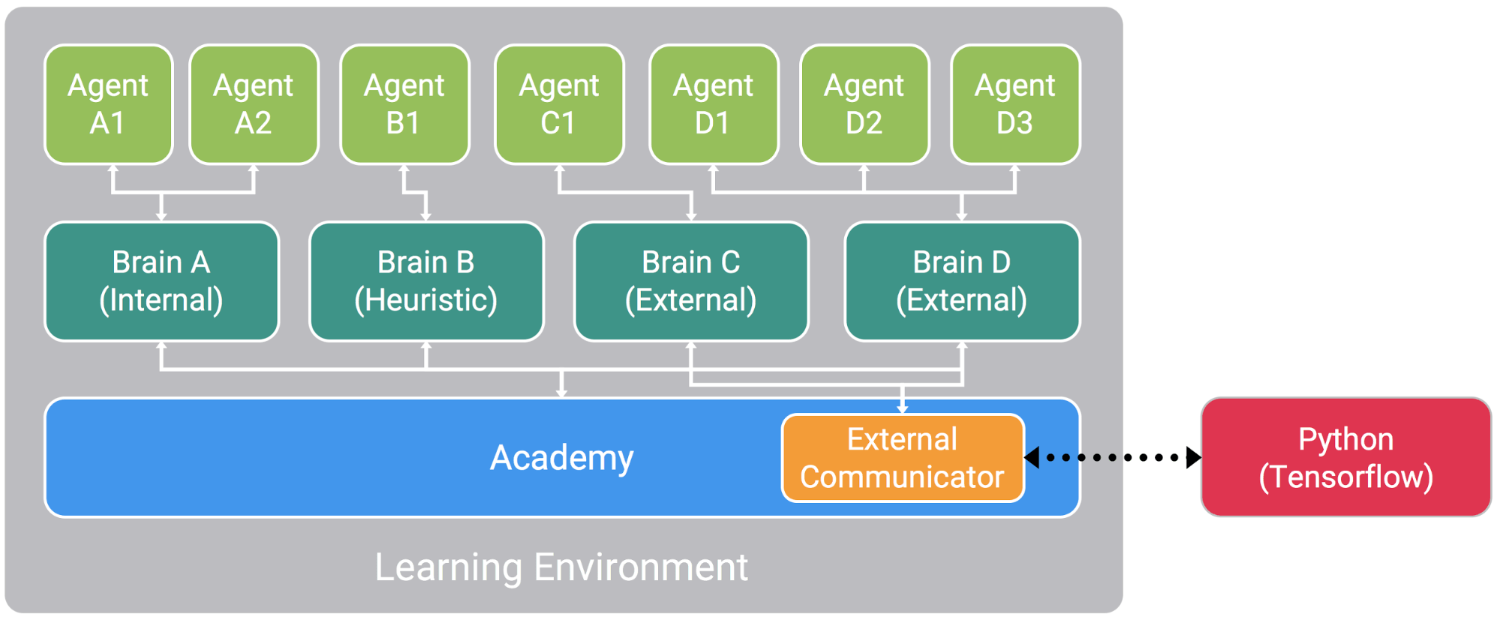

**Agent** – the think that get reward and interact with envirement

**Brain** – What dicated our behavior in can be:

External – Action decision made by let’s say TensorFlow or ML lib of my choice.

Internal – Ready trained model included in project by using TensorFlowSharp

Player – so bacily input from player.

Heuristic – hand coded behvavoiur

**Academy –** The place where we define rules for our training and where our Brains are located .

### **Flexible training scenarios**

So there are unlimited count of scenariours of training you can createte

* **Single-Agent – like cross the road brain**
* **Simultaneous Single-agent** – unit example where multiple object holding the ball
* **Adversarial Self**-**Play**  - agent is play against itself [Dota 2 example](https://blog.openai.com/dota-2/)
* **Cooperative Multi-Agent** – the task where agent needs to cooperate to accomplish the task.
* **Competitive Multi**-**Agent** - need to win together and leader board.(all team sports)
* **Ecosystem** – like world with animals all interacting together.

### Additional features

* **Monitoring agents decision making**  - tool for debugging machine learning
* **Curriculum Learning** – is option to increase difficulty for ML Agent slowly so it can adapt.
* **Complex visual observations** – We are inside unity envirment so we can see as complex as we need
* **Limitation learning** (coming soon) – It

## **TensorFlow**

[github](https://github.com/tensorflow/tensorflow)



Graph for machine learning developed for Googles Machine learning

### TensorFlowSharp

[github](https://github.com/migueldeicaza/TensorFlowSharp)

Allow us to use TensorFlorw from within F# or C#

## Installation

1. Python 3.6 and Anaconda 5.1

You need Python

1. Create conda environment

conda create -n ml-agents python=3.6

activate ml-agents

pip install tensorflow==1.7.1

1. Installing all git

git clone <https://github.com/Unity-Technologies/ml-agents.git> ‘C:\git\ml-agents’

cd C:\git\ml-agents\ml-agents

activate ml-agents

pip install -e .

1. CUDA

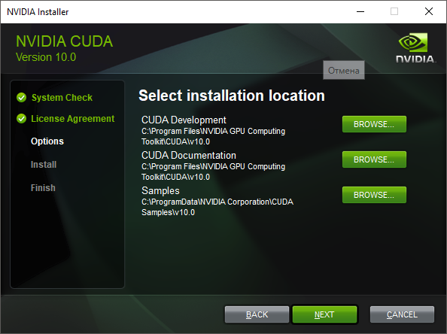

1. Nvidia cuDNN library

Download the files and extract into CUDA location

1. TesorFlow GPU

pip uninstall tensorflow

pip install tensorflow-gpu==1.7.1

1. Testing TensorFlow

import tensorflow as tf

sess = tf.Session(config=tf.ConfigProto(log_device_placement=True))

Small note:

It looks like for cuda 10.0 you need to use tensorflow-gpu=1.11.0

I wasa looking for the issue for some time but in the end it wasa super simple

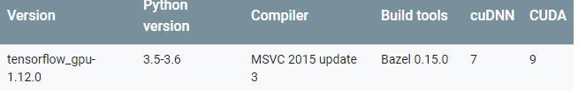

The issue was I installed CUDA 9 but tensorflow support only cuda 9

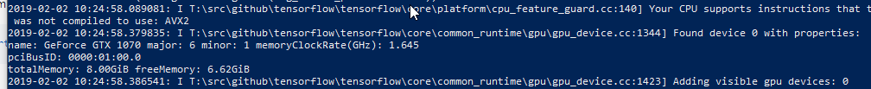

Okay just straight forward followed instructions and it’s worked.

# Jupyter Good tool for data visual ization in python



## Machien learning known problems

### Python version

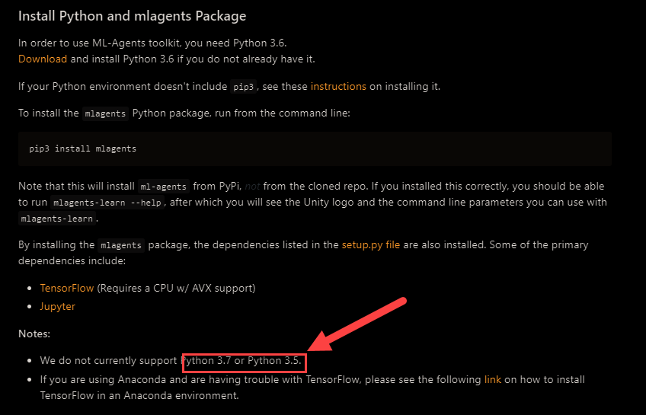

### Dependency issues

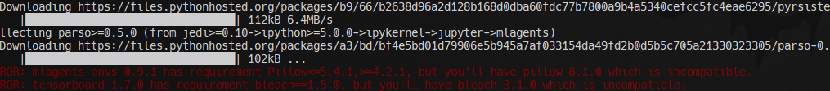

### Need to set brain

